# Sprint 2 Plan

**GOAL**: The goal for this sprint is to first complete the api, then to allow the user to create specific optimization code for their networks, as well as a gui to support that.

**User Stories**

Must Have

User story 1: As a user of the website, I want a GUI for creating perceptron tensorflow networks, so that I can make them in an intuitive fashion.

Task 1: Complete perception API to generate code

Task 2: Create API to download the code

User story 2: As a user of the website, I want to generate the code that optimizes the network as well, as I want an intuitive interface for the entire machine learning pipeline.

Task 1: Write optimization code for the tensorflow modules

Task 2: Write optimization code for the PyTorch modules

Task 3: Create optimization selection on Toolbar

Task 4: Alter API to include optimization information

User story 3: As a user of the website, I want it to tell me basic information about the network, such as number of parameters and number of layers, so I can have a better understanding of the network at a glance.

Task 1: Create text on UI

Could Have

User story 4: As a user of the website, I want operator blocks for abstractions of common architecture patterns, so I can create and visualize networks based off of these patterns easier.

Task 1: create generalized block for abstractions

Task 2: create Toolbar abstraction selection

**TEAM ROLES**

Nicolas Ayala PO

Anish Pahilajani

Kat Negrete

Mahesh Vegiraju

Alex Hutchins

**INITIAL TASK ASSIGNMENT**

Nico: Create optimization blocks in canvas

Alex: Create optimization selection on Toolbar

Kat: Write optimization code for the PyTorch modules

Mahesh: Complete perception API to generate code

Anish: Write optimization code for the tensorflow modules

**INITIAL BURNUP CHART**

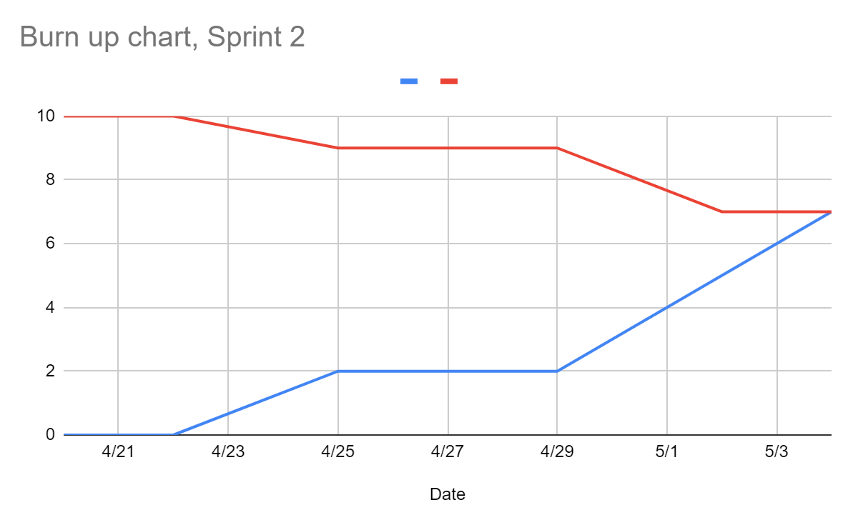

**SCRUM BOARD**

[**https://docs.google.com/spreadsheets/d/1JChBnZUPgPchSqaEMrG6jrwGF1h0Pw-hzuRS_t050S4/edit#gid=1301910593**](https://docs.google.com/spreadsheets/d/1JChBnZUPgPchSqaEMrG6jrwGF1h0Pw-hzuRS_t050S4/edit#gid=1301910593)

**SCRUM TIMES**

**mon-wed-fri afterclass**